Custom Online Maps
Practical Participation offer training & consultancy in using social media tools and strategies in participation projects.
This series of Getting Started guides are designed to offer a flavour of the tools available.

Version 0.1 – December 2007
With Google Maps (maps.google.com)
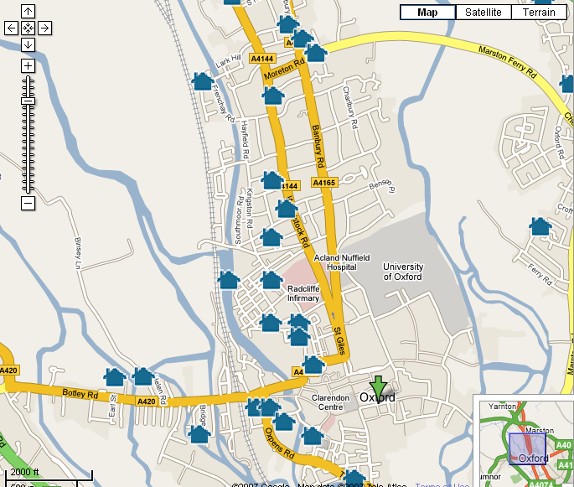
Interactive online maps allow you to annotate a map or Arial photo of your local area.

You might use this to shared your photos of the local area, provide local information or find out what people think of facilities and activities available in the area.

You can share your customized map on the web or through a 3D mapping program.
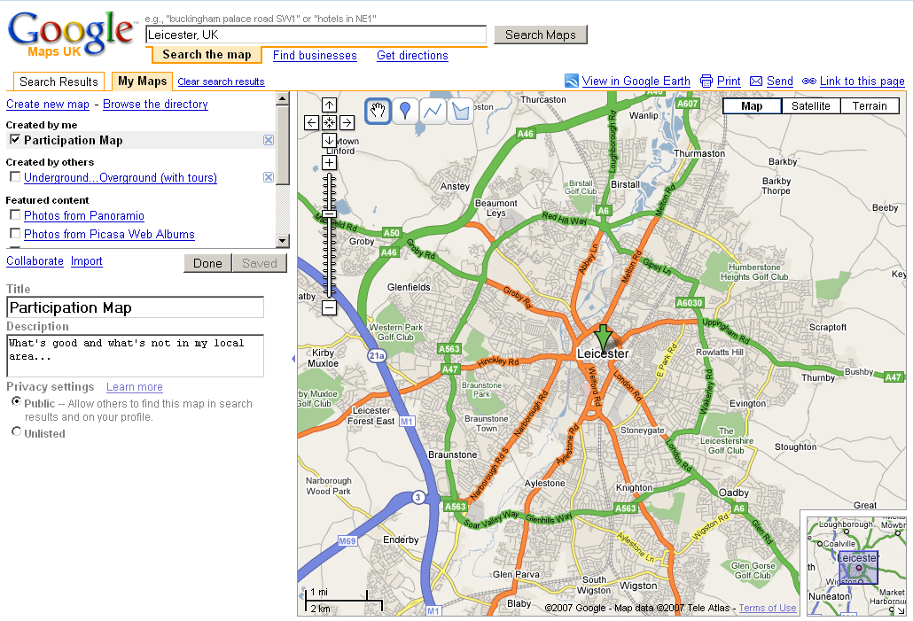
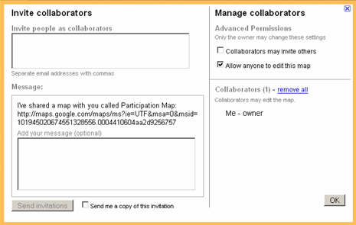
1) Select My Maps and create a new map
2) Give you map a title and description
3) Use the drawing tools to annotate the map. You can include rich text and even embed photos and videos.
4) Select collaborate and choose the collaboration settings for your map
6) Open your map in 3D using Google Earth
5) Share the map link with others so they can add their annotations
Getting Started

Visit http://maps.google.com and select ‘My Maps’. Follow the instructions below to sign in and get started

